Devadarshini J

192124092

29/04/2023

Lab Day 2

Questions:

1. Demonstrate Vector Recycling in R.

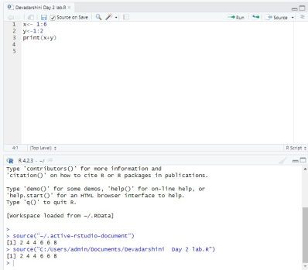

2. Demonstrate the usage of apply function in R

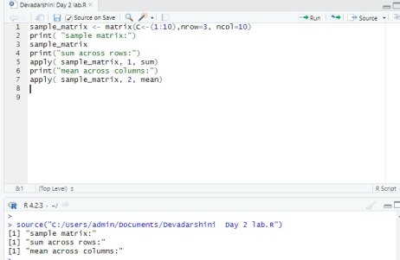

3. Demonstrate the usage of lapply function in R

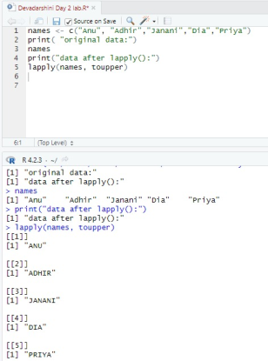

4. Demonstrate the usage of sapply function in R

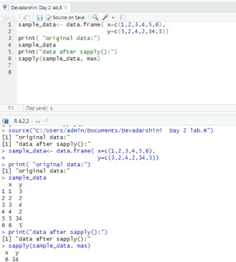

5. Demonstrate the usage of tapply function in R

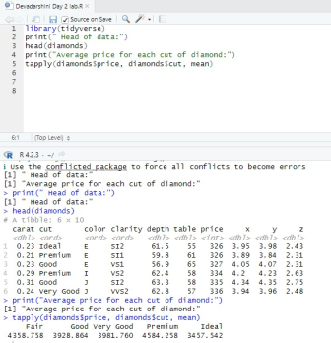

6. Demonstrate the usage of mapply function in R

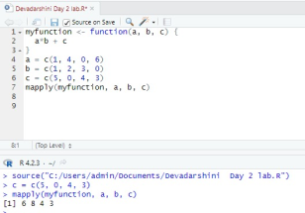

7. Sum of Natural Numbers using Recursion

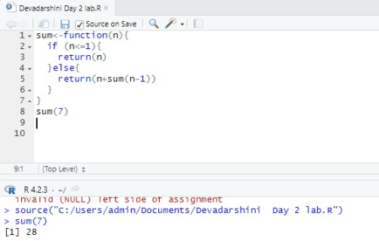

8. Write a program to generate Fibonacci sequence using Recursion in R

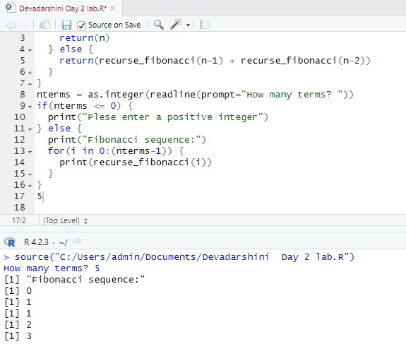

9. Write a program to find factorial of a number in R using recursion.

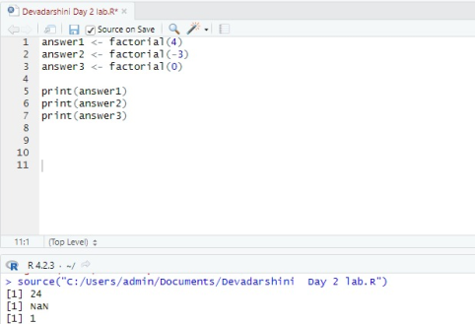

10. Consider two vectors: x=seq(1,43,along.with=Id)

y=seq(-20,0,along.with=Id)

Create a data frame ‘df’ as shown below.

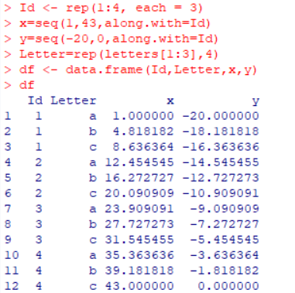

11. Using the data frame ‘df’ in Exercise1, Construct the following data frame.

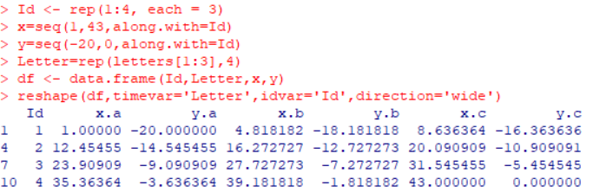

12. Create two data frame df1 and df2:

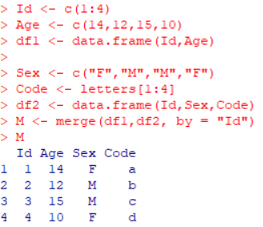

13. Create a data frame df3:

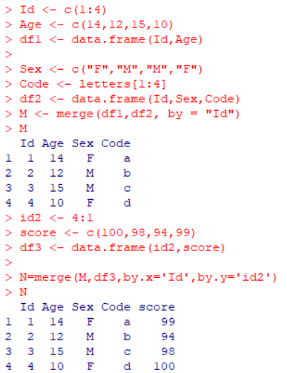

14. Consider the previous one data frame N:

1) Remove the variables Sex and Code

2) From N, create a data frame:

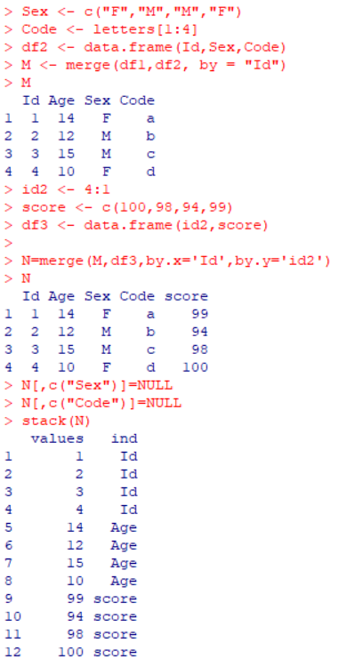

15. For this exercise, we’ll use the (built-in) dataset trees.

a) Make sure the object is a data frame, if not change it to a data frame.

b) Create a new data frame A:

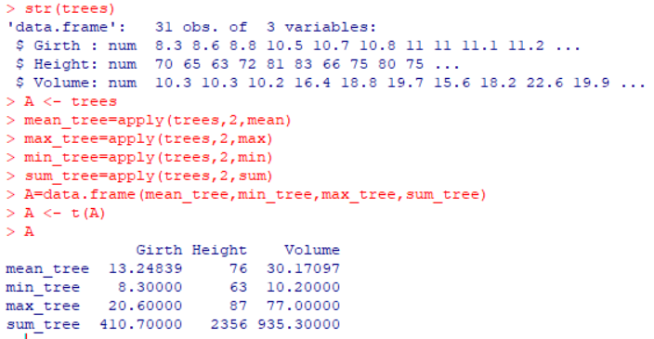

16. Consider the data frame A:

1)Order the entire data frame by the first column.

2)Rename the row names as follows: mean, min, max, tree

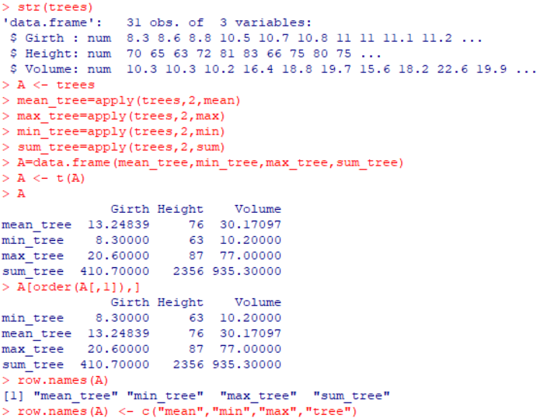

17. Create an empty data frame with column types:

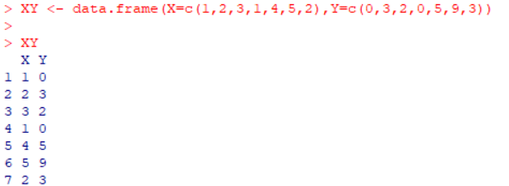

18. Create a data frame XY

1) look at duplicated elements using a provided R function.

2) keep only the unique lines on XY using a provided R function.

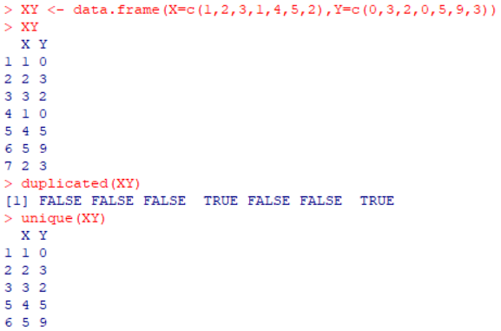

19. Use the (built-in) dataset Titanic.

a) Make sure the object is a data frame, if not change it to a data frame.

b) Define a data frame with value 1st in Class variable, and value NO in Survived variable

and variables Sex, Age and Freq.

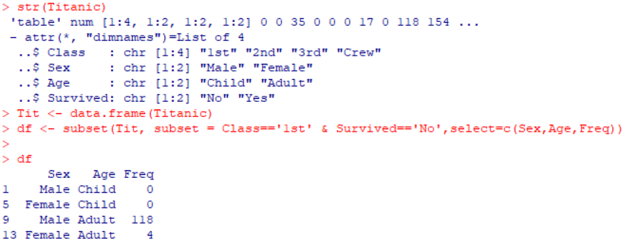

20. a)

Create the following dataframes to merge:

buildings&lt;- data.frame(location=c(1, 2, 3), name=c(&quot;building1&quot;, &quot;building2&quot;,&quot;building3&quot;))

data &lt;-

data.frame(survey=c(1,1,1,2,2,2),location=c(1,2,3,2,3,1),efficiency=c(51,64,70,7,80,58))

The dataframes, buildingsand datahave a common key variable called, “location”.

Use the merge() function to merge the two dataframes by “location”, into a new

dataframe,“buildingStats”.

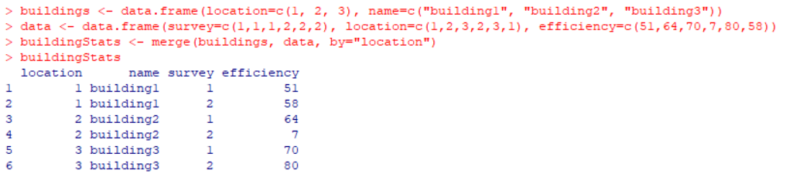

b)

Give the dataframes different key variable names:

buildings&lt;- data.frame(location=c(1, 2, 3), name=c(&quot;building1&quot;,&quot;building2&quot;, &quot;building3&quot;))

data &lt;- data.frame(survey=c(1,1,1,2,2,2), LocationID=c(1,2,3,2,3,1),

efficiency=c(51,64,70,71,80,58))

The dataframes, buildings and data have corresponding variables called, location, and

LocationID. Use the merge() function to merge the columns of the two dataframes by the

corresponding variables.



21. a)InnerJoin:

The R merge() function automatically joins the frames by common variable names. In that

case, demonstrate how you would perform the merge in Exercise 11a without specifying the

key variable.

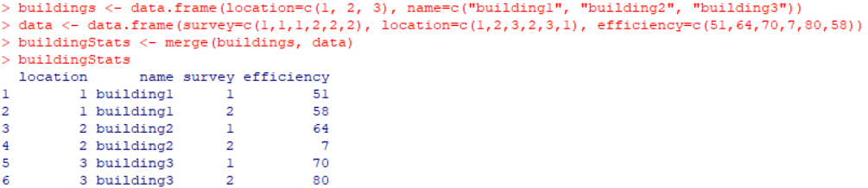

b)OuterJoin:

Merge the two dataframes from Exercise 11a. Use the “all=” parameter in the merge()

function to return all records from both tables. Also, merge with the key variable, “location”.

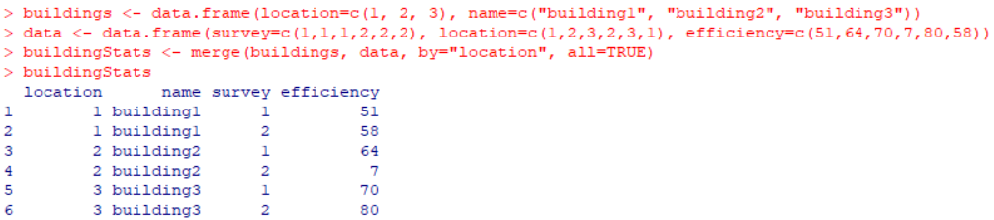

c)Left Join:

Merge the two dataframes from Exercise 11a, and return all rows from the left table. Specify

the matching key from Exercise 11a.

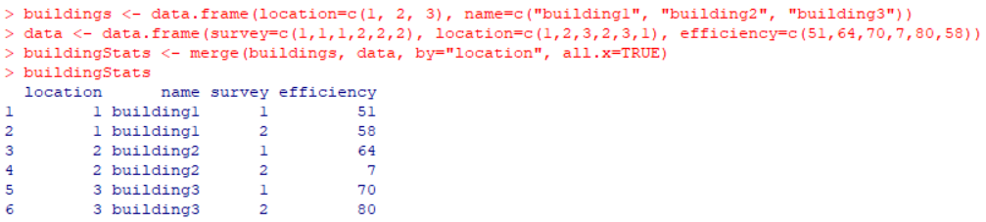

d)Right Join:

Merge the two dataframes from Exercise 11a, and return all rows from the right table. Use

the matching key from Exercise 11a to return matching rows from the left table.

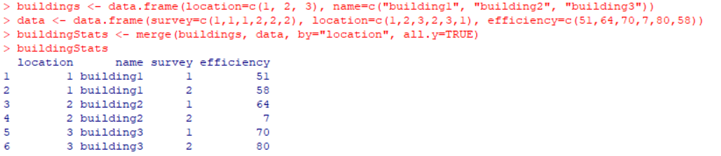

e)Cross Join:

Merge the two dataframes from Exercise 11a, into a “Cross Join” with each row of

“buildings” matched to each row of “data”. What new column names are created in

“buildingStats”?

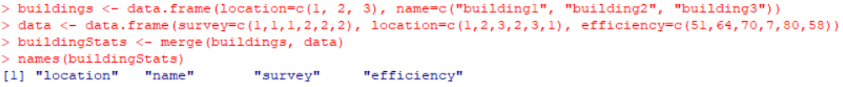

22. To join two data frames (datasets) vertically, use the rbind function. The two data frames must

have the same variables, but they do not have to be in the same order.

Merge the rows of the following two dataframes:

buildings&lt;- data.frame(location=c(1, 2, 3), name=c(&quot;building1&quot;,

&quot;building2&quot;, &quot;building3&quot;))

buildings2 &lt;- data.frame(location=c(5, 4, 6), name=c(&quot;building5&quot;, &quot;building4&quot;, &quot;building6&quot;))

Also, specify the new dataframe as, “allBuidings”.

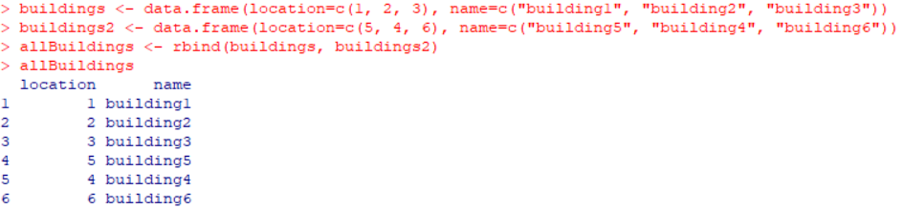

23. Create a new dataframe, buildings3, that has variables not found in the previous dataframes.

buildings3 &lt;- data.frame(location=c(7, 8, 9), name=c(&quot;building7&quot;, &quot;building8&quot;, &quot;building9&quot;),

startEfficiency=c(75,87,91))

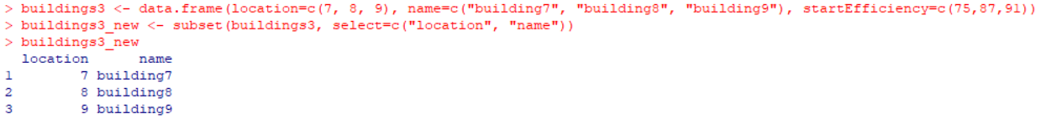

24. Instead of deleting the extra variables from buildings3 . append the buildings, and buildings2

with the new variable in buildings3, (from Exercise 14). Set the new data in buildings and

buildings2 , (from Exercise 13), to NA.

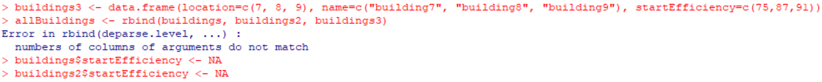

25. Construct the following data frame ‘country’.

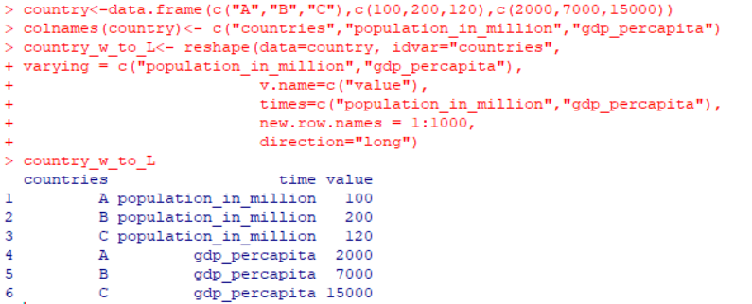

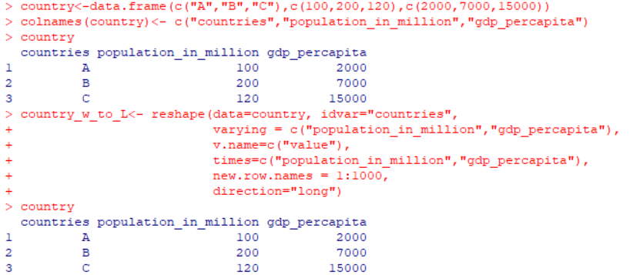

26. 1. Melt airquality data set and display as a long – format data ?

2. Melt airquality data and specify month and day to be “ID variables” ?

3. Cast the molten airquality data set .

4. Use cast function appropriately and compute the average of Ozone, Solar.R , Wind

and temperature per month ?

27. Consider the following data present. Create this file using windows notepad . Save the

file as input.csv using the save As All files(\*.\*) option in notepad.

